 | Reg. No:  SRI RAMAKRISHNA ENGINEERING COLLEGE,COIMBATORE  Regulation- 2020 (ES)  (Autonomous Institution, Reaccredited by NAAC with ‘A+’ GRADE Approved by AICTE and Permanently affiliated to Anna University, Chennai)  AUTONOMOUS EXAMINATIONS - AUGUST'2022
B.TECH - INFORMATION TECHNOLOGY
20EE262 - BASICS OF ELECTRICAL AND ELECTRONICS ENGINEERING
Answer ALL questions
Duration: 2 Hrs 30 min |  |  |  |  |  | Maximum: 70 Marks
 |  |  |  |  |  |  |  | PART - A |  |  | (5 x 1 = 5 Marks)
1. | A circuit consists of two resistances, R1 and R2 in parallel. The total current passing through the circuit is I_{T}. The current passing through R1 is ______.
 | a) (I_{T}R1)/(R1+R2) |  |  |  | b) I_{T}(R1+ R2)/ R1 |  |  |  | c) (I_{T}R2)/(R1+R2) |  |  | d) (I_{T}R1+ R2)/ R2
2. | Maximum power is transferred when load resistance is________.
a) equal to half of the source resistance b) Equal to zero
c) Equal to source resistance d) unity

3. | The reluctance of magnetic circuit is defined as _________.
a) Magneto motive force b) ratio of magneto motive force to magnetic flux
c) ratio of magnetic flux to magnetic force d) ratio of voltage to current

4. | The direction of induced e.m.f. in a coil can be found by _________.
a) Laplace's law b) Lenz's law
c) Fleming's right hand rule d) Kirchhoff's voltage law

5. | A moving iron type ammeter has few turns of thick wire so that ___.
a) Resistance is less b) Sensitivity is high
c) Damping is effective d) Scale is large
 |  |  |  |  |  |  | PART - B |  |  | (5 x 3 = 15 Marks)
6. |  | State Kirchhoff’s voltage and current law.
7. |  | Find the value of current I coming out of the battery for the circuit in the figure 1?  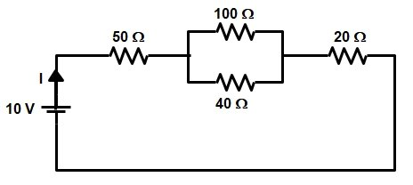  Fig.1
8. |  | Distinguish between self and mutual inductance.
9. |  | Why calibration of instrument is important?
10. |  | Explain the operation of NPN and PNP transistors.
 |  |  |  |  |  |  |  | PART - C |  |  | (5 x 10 = 50 Marks)
Q.No: 11 Compulsory Question
Q.No: 12 to 17 Answer any FOUR Questions
Compulsory Question:
11. |  |  | i) | Calculate the Thevenin’s voltage, Thevenin’s resistance and the load current. Consider the load resistor R_{L} is 40 Ω and E_{TH} is 10 V and Thevenin’s Equivalent Circuit for figure 2.  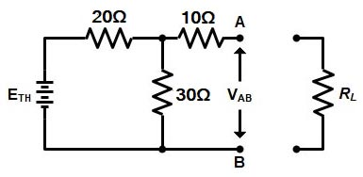  Fig. 2 |  |  |  |  |  |  |  |  | (5)
 |  |  | ii) | Determine the Norton’s current for the given circuit across the load resistance R_{L} shown in the figure 3.  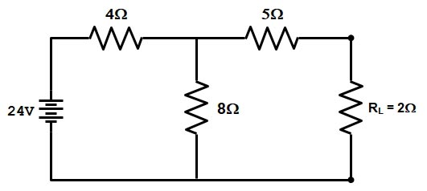  Fig. 3 |  |  |  |  |  |  |  |  | (5)
12. |  |  | i) | Apply Superposition theorem, calculate current flowing through 2 Ω resistor shown in the figure 4.  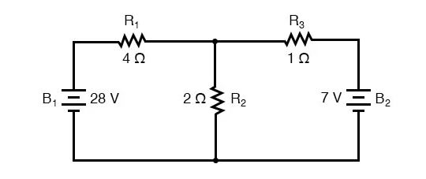  Fig. 4 |  |  |  |  |  |  |  |  | (5)
 |  |  | ii) | State Maximum power transfer theorem. Apply the specified condition and derive the open circuit voltage, thevenin’s resistance and maximum power transferred. |  |  |  |  |  |  |  |  | (5)
13. |  |  |  | With a neat sketch, Explain the construction, working, types, applications and advantages of single phase transformer. |  |  |  |  |  |  |  |  | (10)
14. |  |  |  | Classify the types of measuring instruments and explain briefly. |  |  |  |  |  |  |  |  | (10)
15. |  |  |  | Explain the construction, operation, merits and demerits of Permanent Magnet Moving Coil instrument. |  |  |  |  |  |  |  |  | (10)
16. |  |  |  | Explain the construction, working, VI characteristics, applications and advantages of PN junction diode. |  |  |  |  |  |  |  |  | (10)
17. |  |  |  | With a neat sketch, explain the construction, principle and working of JFET. Give their merits, demerits and applications. |  |  |  |  |  |  |  |  | (10)
*****

